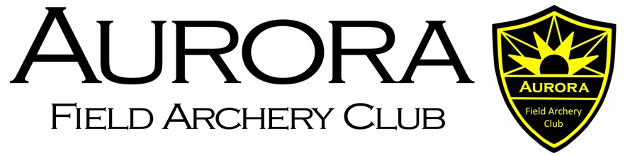
Membership Application
Full Name
Address
Town/City
County
Postcode
Date of Birth
Email address
Telephone | Home: | Mobile:
NFAS No. *

*Applicants who are not members of the National Field Archery Society will need to complete an appropriate training course dependent on the type of membership required. (Not applicable for associate membership).

Membership Category

Category | Criteria | Fee (£) | Tick Here
Adult | 16 years and over | 30.00
Junior | Under 16 years | 15.00
Family | Parent(s) and up to 2 children | 50.00
Associate | Non-shooting member | 5.00
New Member Application only  Proposed/Seconded by: |  | Either the person proposing or seconding the application must be a member of the AURORA Field Archery Club Executive Committee
Proposed: |  | Signature:
Seconded: |  | Signature:
(Please make cheques payable to AURORA FAC)
I have read, understood, and agree to abide by the constitution and rules of Aurora Field Archery Club and will be a member of the National Field Archery Society and abide by its constitution and rules.

Signature:............................................................................... Date:..............................

Membership is granted based on the applicant being willing to assist in the organisation and running of open shoots and club days when possible.

Here at Aurora Field Archery Club we take your privacy seriously and will use your personal information only to provide the services you have requested from us e.g. NFAS open shoot entry, coaching and Club membership administration.

Your information will never be shared with any third party outside the club and Aurora Field Archery club will never contact you directly for any marketing purposes.

For further information on how your information is used, how we maintain the security of your information and your rights to access the information we hold about you, please contact us by email at data-protection@aurorafac.co.uk.

